Trevor Shortlidge
CIS17b

Survey Engine – Personal Project

Description:
This program simulates a survey engine. First you Register/Login, if your login has failed with the database it will prompt you to re-log in. If your login is successful with the database it saves your session with cookies and local storage. It then will redirect you to another page(the survey) to create a survey.You first must select a title. By clicking submit title it will store the title. After words if will ask you what question number you would like for the survey. Afterwards you type in the question you would like. Followed by the questions answers. When you have finished completing your survey. You can submit and it will bring you to all the surveys list. By clicking the survey you have just created you can choose which answer you would like for each. After selecting your answers for each question in the survey. You can goto the results page and see how many people picked so and so for each question. For confidentiality the users names wont appear next to the answer they chose. It will simply say a percentage of people selecting that answer for each question in the survey. Once you have finished you can log out or go back to the main page and create a new survey.

Rules:
-User must register an account(deals with regular expressions)
-User must then login with regular expressions to access the site.
-Choose a title
-Enter a question number (will only allow integers)
-Enter in your question
-Enter in all of the answers(up to 5)
-Results page-> choose a survey to do
-Answer the questions the survey asks
-Submit and see the results of the survey compared to other people
-Log out clears cookies/localstorage/session
-Main page will let you create another survey and continue the cycle
-If needed to edit/delete/view users, register on the admin page or login
-Admin page -> views/edits/deletes users
Code:
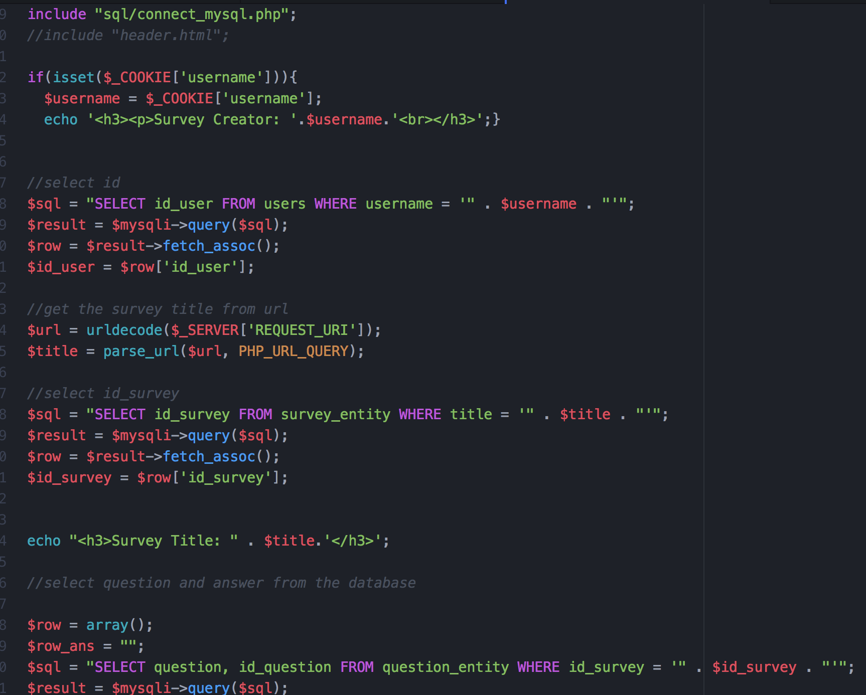

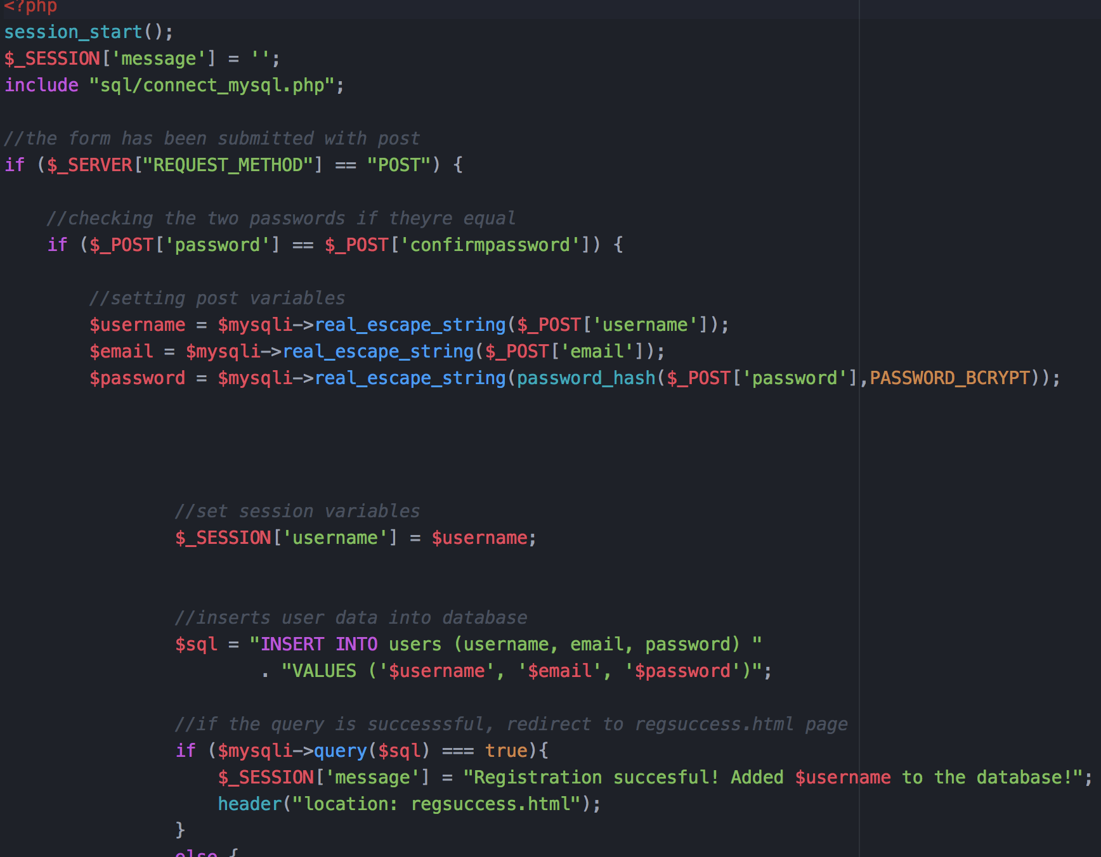

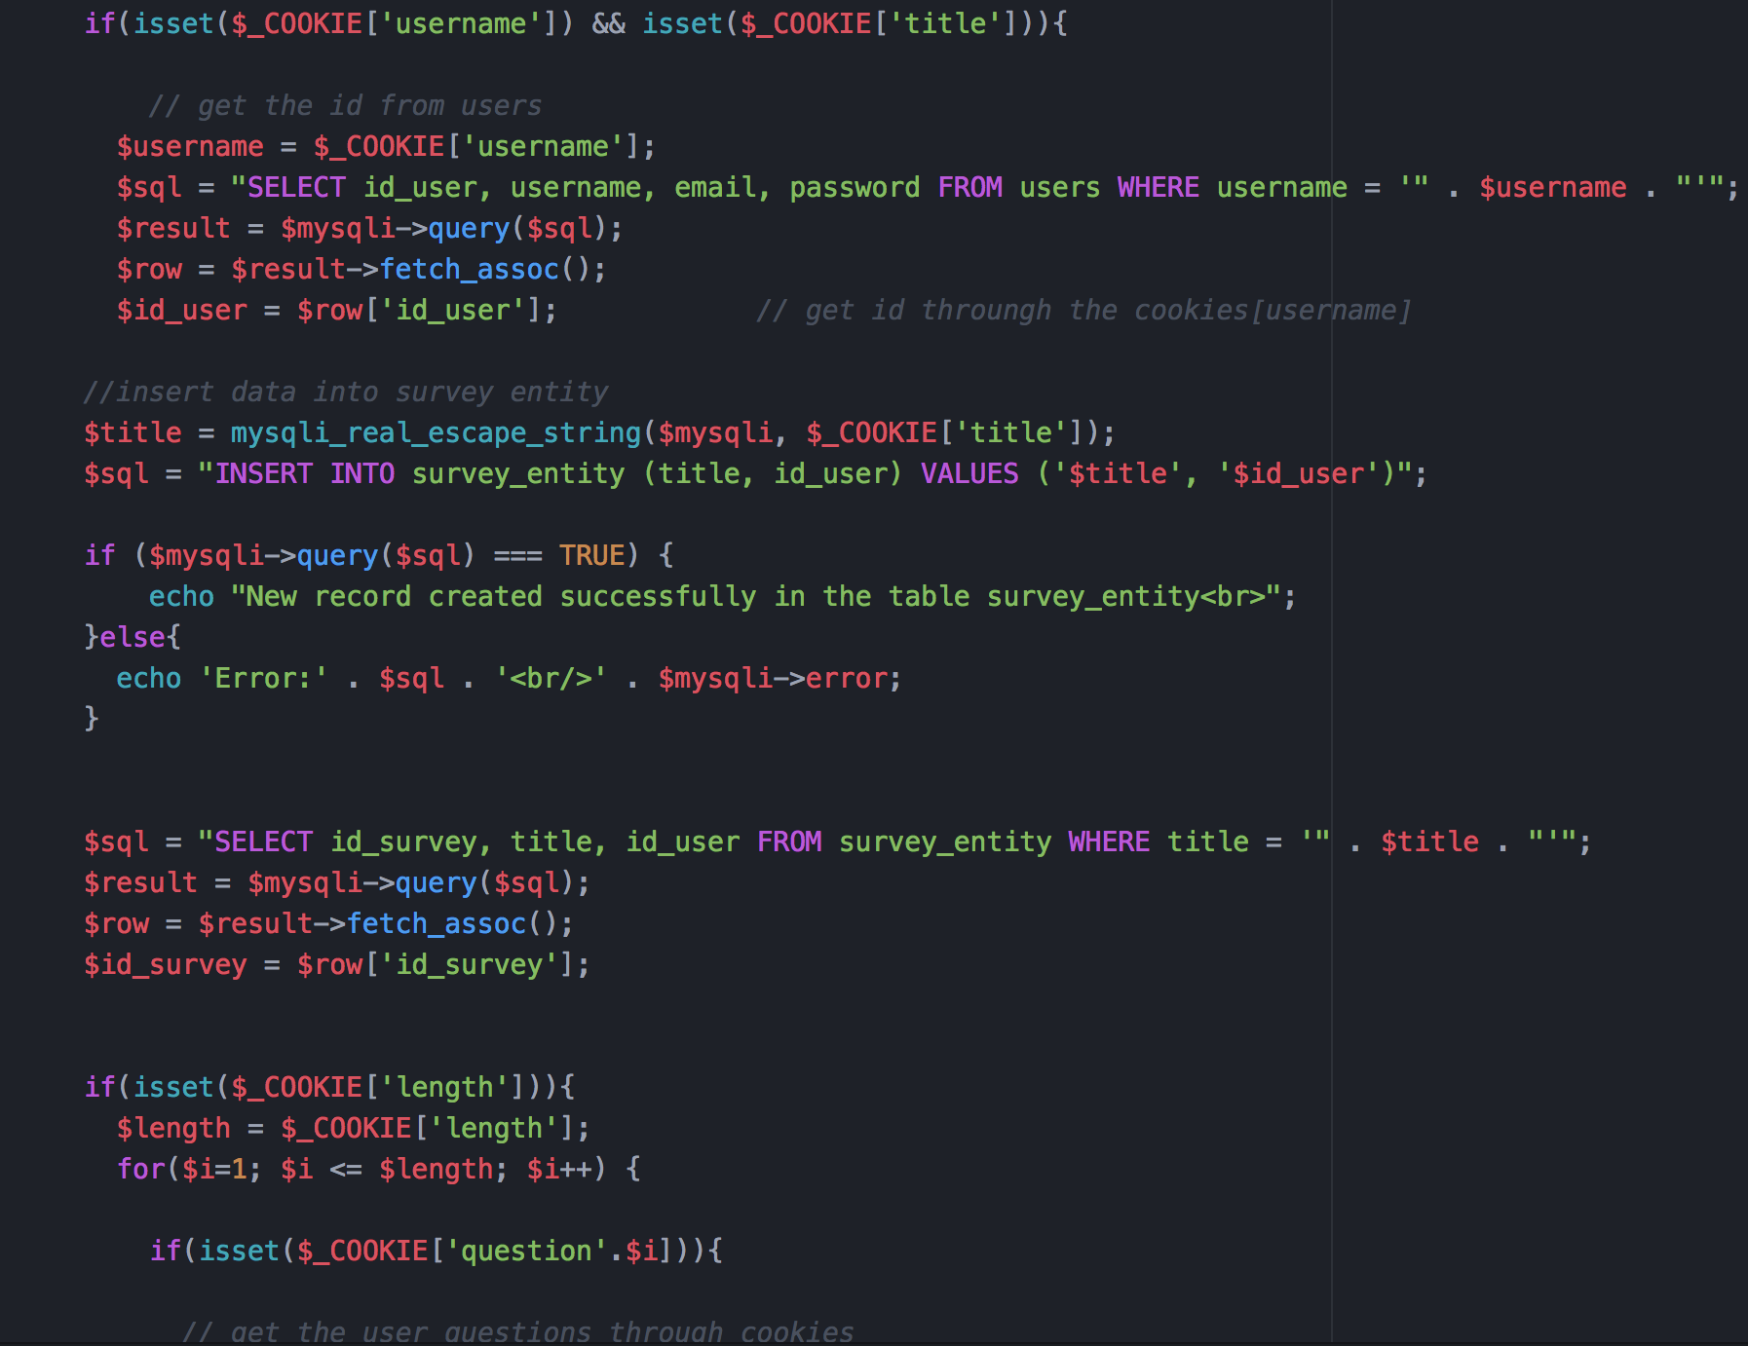
ScreenShots:

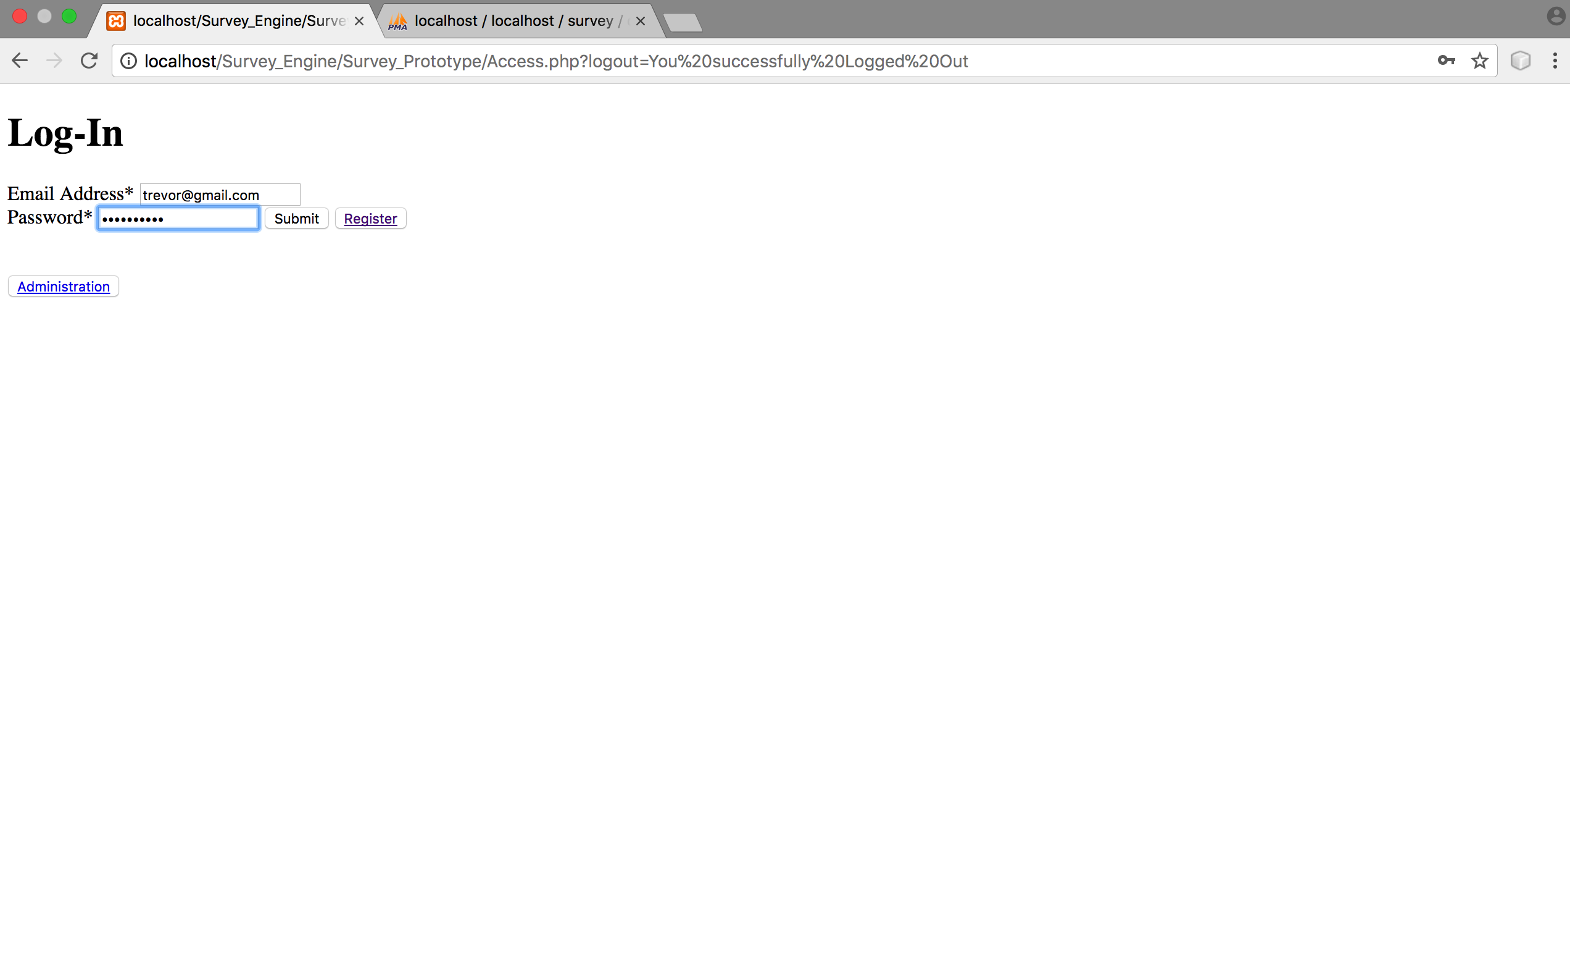

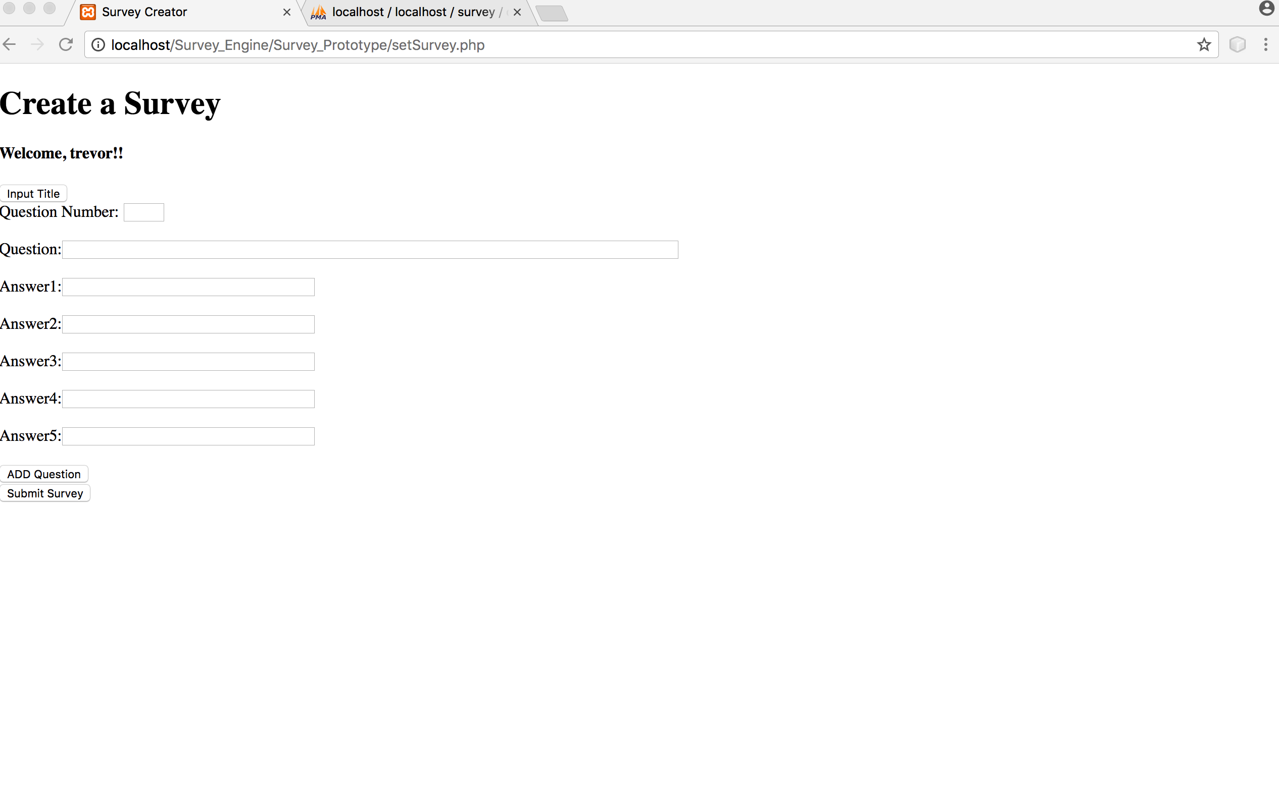
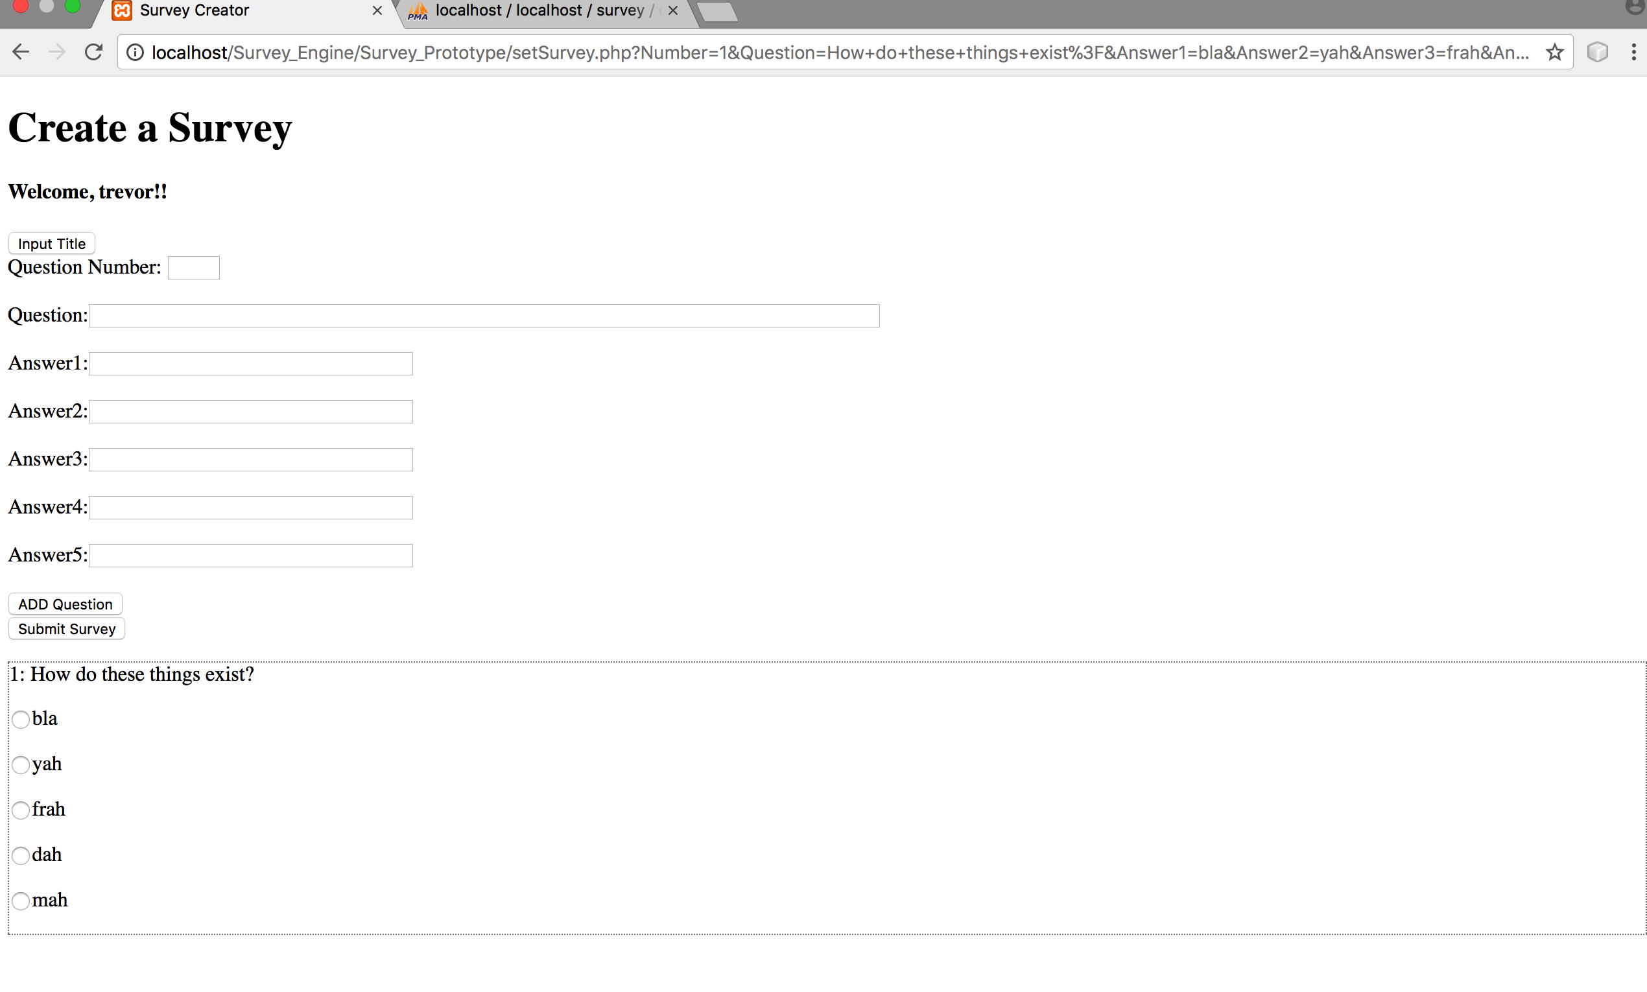

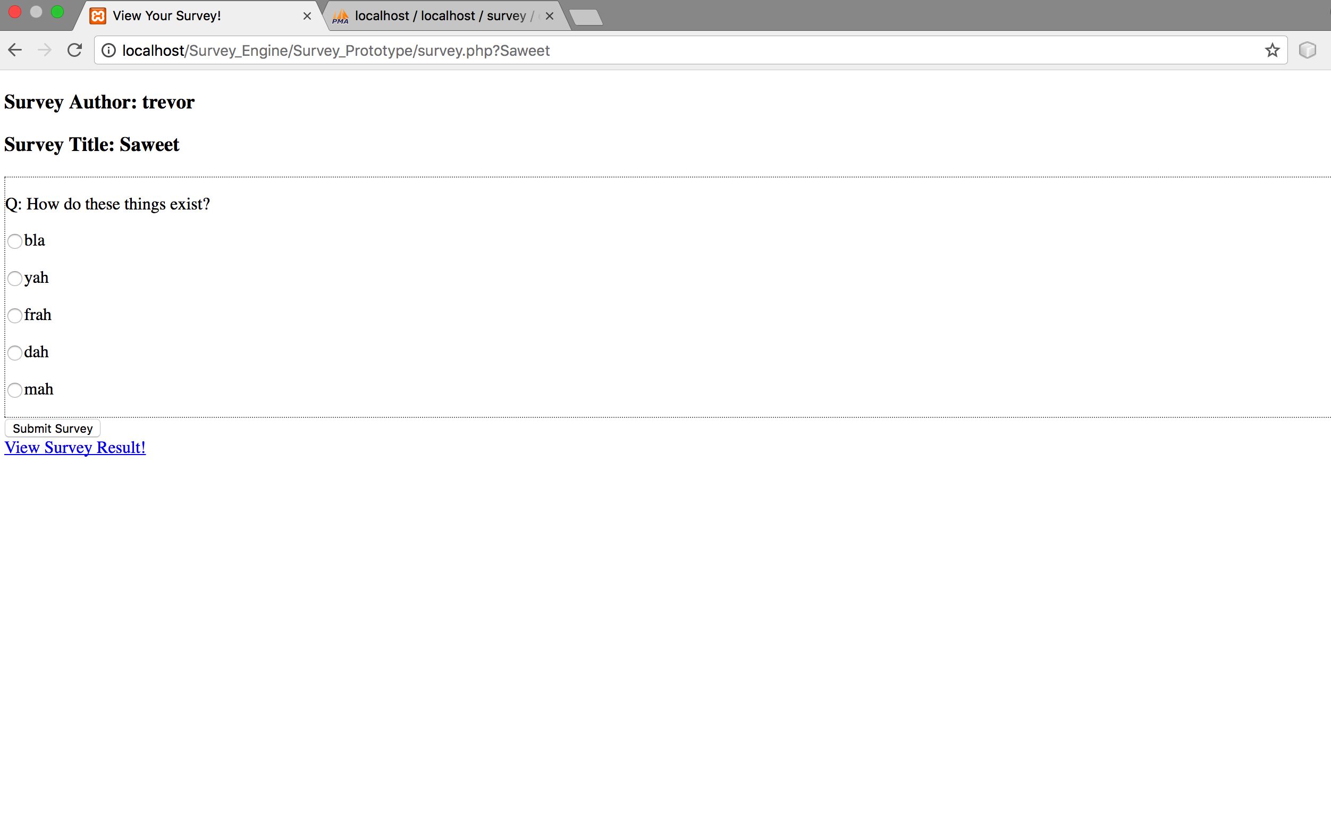
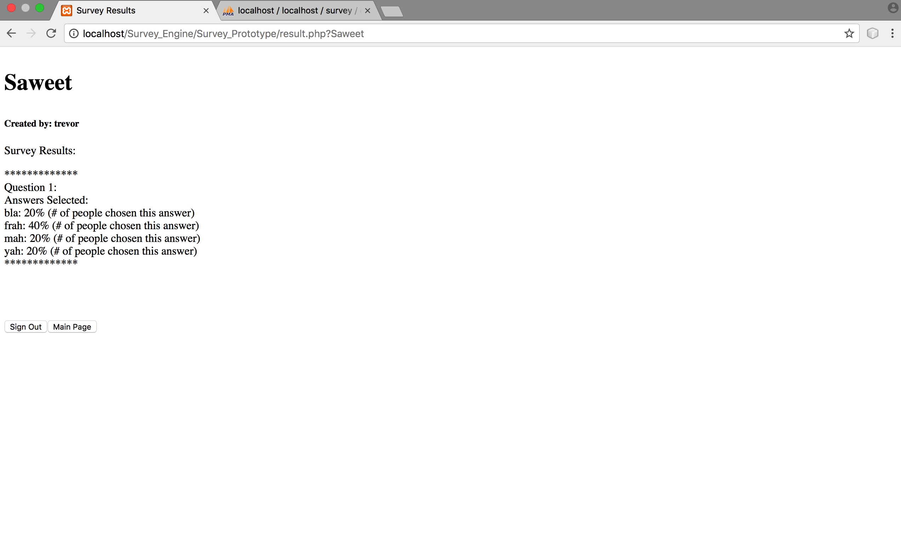



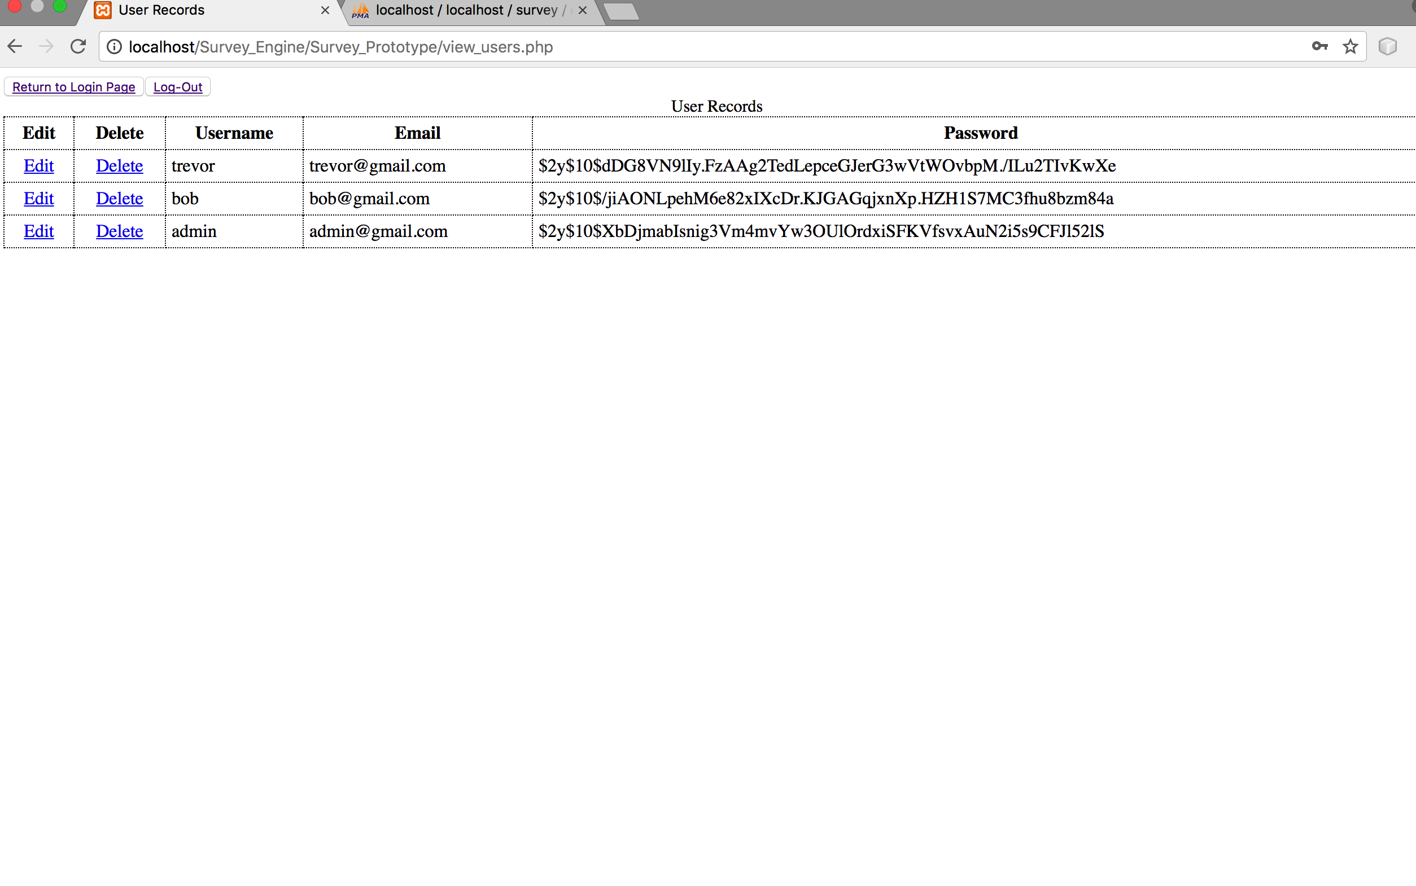



Github link: https://github.com/tshortlidge/ShortlidgeTrevor_CIS_CSC_17b_Fall2017/tree/master/Projects/Survey%20Engine

